Join us for Vacation Bible School

College Hill Heights Baptist CHurch

Saturday June 26th

9:30am-12:30pm

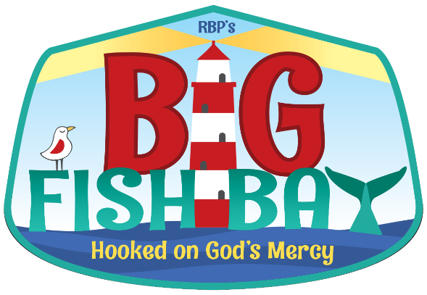
Big Fish Bay is a nautical theme where kids explore an exciting bay, fish off the pier, and venture out to sea, complete with a lighthouse, tall ships, and coastal animals. During lesson time, kids will embark on a journey into the life of Jonah. They’ll encounter God’s mercy and see how His compassionate heart was most fully expressed in Jesus’ death and resurrection. Seeing God’s mercy, sharing God’s mercy—kids will be “Hooked on God’s Mercy."

Morning VBS will include:
- Bible lesson for kids grades K3-6th
- Outdoor Games
- Delicious lunch
- Team competition
- Praise and Worship Music
- and More…

Theme Verse: “The LORD is merciful and gracious, slow to anger, and plenteous in mercy.” Psalm 103:8

Register Today!!!
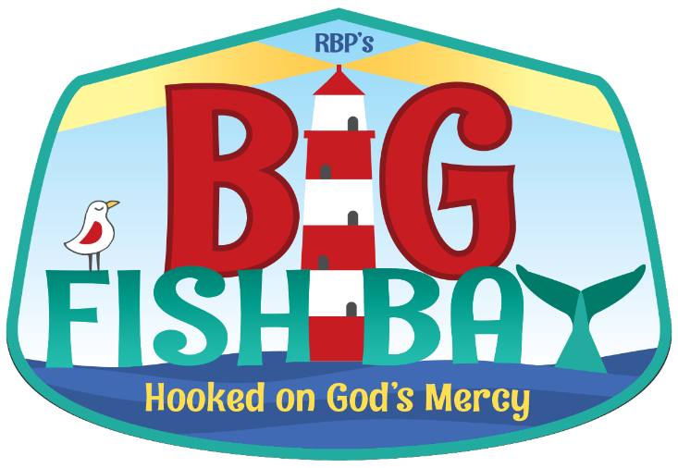
Registration Form
(One Per Child)

College Hill Heights Baptist CHurch

VBS

Saturday June 26th

9:30am-12:30pm

Childs Name: ______________________________________ Gender: _____________
Childs Age: _______ Date of Birth: ___________ Last Grade Completed: ______
Name of Parents: ________________________________________________________
Street Address: __________________________________________________________
City: ______________________________ State: ___________ Zip: ________________
Emergency Contact: _____________________________________________________
Relationship to Child: ____________________________________________________
Cellphone Number: ______________________________________________________
Parents Email: ___________________________________________________________
Home Church: ___________________________________________________________
Allergies or Other Medical Conditions: ____________________________________

Please e-mail completed form to cjbwarren@yahoo.com

